**Chapter 3**

**Data set**

**3.1 American Sign Language:**

American sign language is using to communicate between deaf community and normal community. However, there are only 2.5 million ~ 5.0 million speak which significantly limit the number of that they can easily communicate with [12].

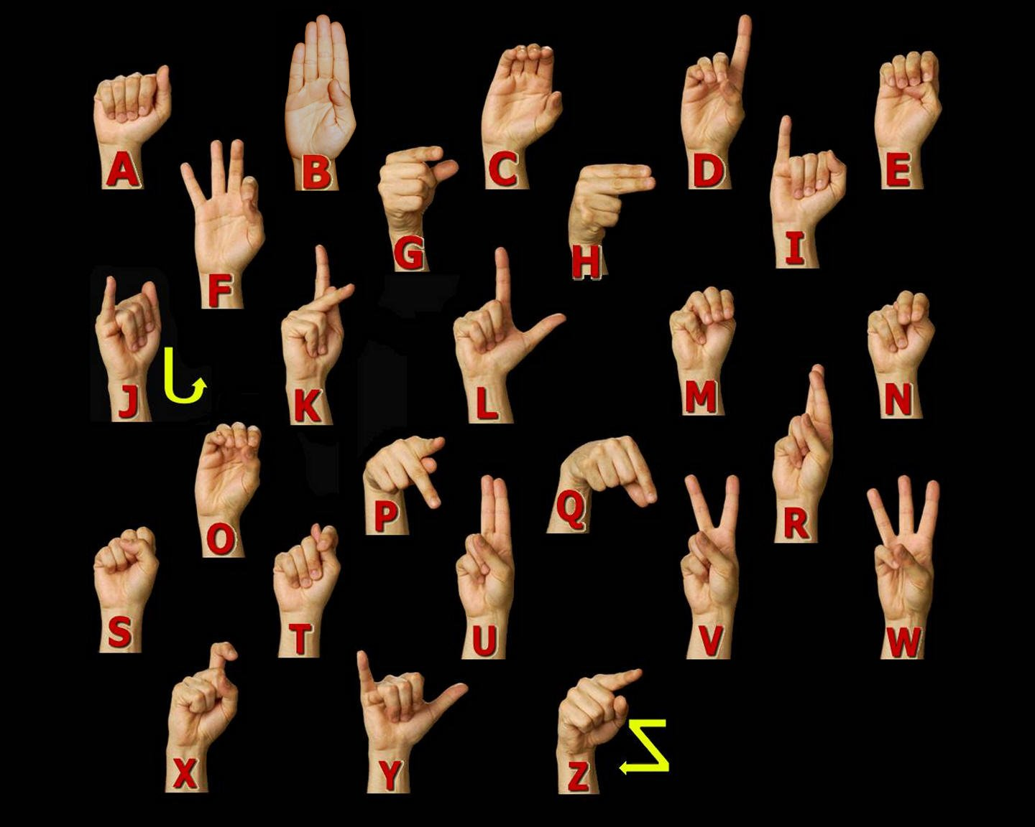

**American Sign language Manual Alphabet [13].**

American Sign Language is implemented from French sign language which was introduced by Thomas Hopins Gallaudet in United States. ASL is similar to French sign language; Individuals who speak American Sign Language are able to effectively communicate in French Sign Language. A variation of American Sign Language also exits. Similarly, to English which is international language, but it has unique variations between English spoken in England, United States or Australian, there are separate difference that have changed in sign language (Stokoe, 2005).

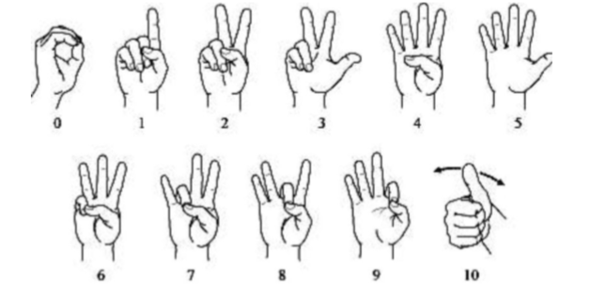

**Figure 1. American Sing language numbers.[13]**

**3.2 Characteristics of American Sign Language:**

* American Sign language is an entire visual-gestural dialect with its very own language structure, vocabulary, and linguistic structure.
* Like other sign language, it utilizes the hands, the body, and face looks (counting mouth developments) to express significance and the eyes to see meaning.
* Hand - to-hand connection is especially critical in ASL since it has no composed frame. There are, in any case, documentation frameworks that are utilized for recording signs on paper.
* ASL is separate from English and is unique from other signed languages. An example of the distinctiveness of signed languages from each other and from the surrounding spoken language(s) is that, although English is the shared spoken language of the U.S., Canada, and Britain, signers of ASL do not understand signers of British Sign Language (BSL).

**3.3. Statistics** **about sign language use in Canada:**

In Canada, Statistics Canada reports that as indicated by the 2006 Census 8,995 people revealed a gesture-based communication just like their primary language or one of their first languages, as gave beneath.

|  |  |
| --- | --- |
| American Sign Language | 2,485 |
| Quebec Sign Language | 730 |
| Sign languages, not included elsewhere | 5,780 |

**Table 1 : Statics about Sign Language as a Mother Tongue [14].**

In addition, Statistics Canada reports that as per the 2006 Census 43,090 people reported knowledge of a gesture-based communication, as provided below.

|  |  |
| --- | --- |
| American Sign Language | 11,110 |
| Quebec Sign Language | 730 |
| Sign languages, not included elsewhere | 5,780 |

**Table 2: Statics about Knowledge of Sign Languages[14].**

**3.4 Dataset and variables:**

I have created my own data set. This dataset was a collection of 36 which contain A to Z alphabet and 0 to 9 numbers digit. In my dataset consist of A to Z alphabet and 0 to 9 numbers where I have used right hand to capture 1200 images for specific alphabet and numbers. After that I implement code which convert flip image to right to left hand image. The height and width ratios vary significantly but average approximately 50X50 pixel. The A dataset contains over 100,000 images in gray scale color. Additionally, People who want to add their images to this dataset than they can add. Below figure shows a sample image of alphabet A, B, C respectively.

|  |  |  |  |
| --- | --- | --- | --- |
|  |  | |  |
| **A** | **B** | **C** | |

Figure 2: Sample images of my Data set.

|  |  |
| --- | --- |
| **Property** | **Description** |
| Alphabets | A to Z |
| Numbers | 0 to 9 |
| Color | Gray Scale |
| Dimensions | 50x50 |
| Height | 50 pixels |
| Width | 50 pixels |
| File type | JPEG |

**Table 3: Dataset Description and Image property**

**3.5 Capturing Images for Dataset**

Used for detecting hand gesture using skin color, there are different approaches including skin color-based methods.In my case, after detecting and subtracting the face and other background, skin recognition and a contour comparison algorithm were used to search for the hand and discard other background color objects for every frame captured from a webcam or video file.Before getting the frames from a webcam, I loaded the prototypes of hand gestures as shown in Figure 3.2: **palm to extract their contours and saved the four for comparison with the contours of the skin detected area of every frame. After detecting the skin area for every frame captured, we compared the contours of the detected areas with the previously loaded hand posture template contours to eliminate other skin like objects existing in the image. If the contour comparison of the detected skin area complies with any one of the stored hand postures contours, a small image will enclose the hand posture area only. As shown in Chapter 4, a small image (50×50 pixels) will be used to extract the keypoints using the SIFT algorithm for hand posture recognition. In Chapter 5, PCA will be used for extracting the features of the small image (160×120 pixels) to recognize the hand posture.**